Indian Institute of Information Technology, Nagpur



Registration and Feedback System

Database and Management System

Computer Science & Engineering

5rd Semester

Prepared By:

|  |  |
| --- | --- |
| Raj Aryan  (BT19CSE043) | Prateek Shende    (BT19CSE051) |
| Sarthak Gupta (BT19CSE054) | |

**PART I**

**FEEDBACK SYSTEM**

CREATE TABLE STUDENT_DETAILS(

    STUDENT_ID INTEGER PRIMARY KEY,

    ACADEMIC_YEAR INTEGER NOT NULL,

    SEMESTER INTEGER NOT NULL,

    BRANCH VARCHAR(4),

    SECTION VARCHAR(5),

    COURSE VARCHAR(20)

);

CREATE TABLE FEEDBACK_DETAILS(

    FEEDBACK_ID INTEGER AUTO_INCREMENT PRIMARY KEY,

    FEEDBACK_DATE DATE,

    STUDENT_ID INTEGER,

    COURSE VARCHAR(20),

    Q1 INTEGER,

    Q21 INTEGER,

    Q22 INTEGER,

    Q23 INTEGER,

    Q24 INTEGER,

    Q25 INTEGER,

    Q3 INTEGER,

    Q4 INTEGER,

CONSTRAINT FD_K FOREIGN KEY (STUDENT_ID) REFERENCES STUDENT_DETAILS (STUDENT_ID)

);

**The student_details will be storing all the details about the students who have filled the Feedback form and feedback_details will be storing the information about what the students have filled in the form. The link between these two table schemas will STUDENT_ID through which you can select all the form entries the student has filled in all different Courses.**

The Entities along with their Attributes have been listed below –

|  |
| --- |
| **FEEDBACK_DETAILS** |
| FEEDBACK_ID (PK)(AI) |
| FEEDBACK_DATE |
| STUDENT_ID (FK) |
| COURSE |
| Q1 |
| Q21 |
| Q22 |
| Q23 |
| Q24 |
| Q25 |
| Q3 |
| Q4 |

|  |
| --- |
| **STUDENT_DETAILS** |
| STUDENT_ID (PK) |
| ACADEMIC_YEAR |
| SEMESTER |
| BRANCH |
| SECTION |
| COURSE |

Here, the underlined Attributes denote Primary Keys and (FK) represents.

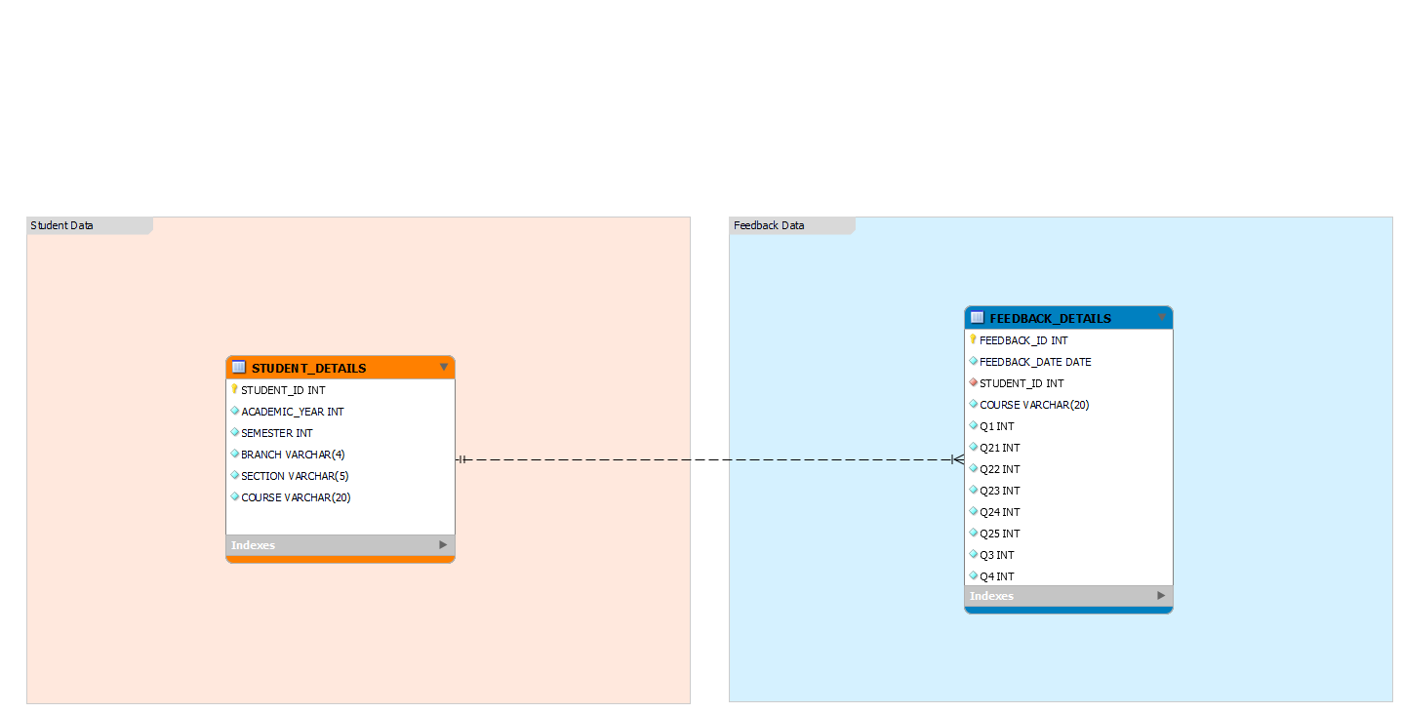The Entity Relationships among all these Entities will look like -

**PART – II**

**REGISTERATION SYSTEM**

CREATE TABLE STUDENT_FORM(

    JEE_ROLL_NO INTEGER UNIQUE,

    FORM_ID INTEGER AUTO_INCREMENT PRIMARY KEY,

    DATE_OF_REG DATE

);

CREATE TABLE STUDENT_REG_DETAILS(

    JEE_ROLL_NO INTEGER PRIMARY KEY,

    SNAME VARCHAR(30),

    GENDER VARCHAR(1),

    BLOOD_GROUP VARCHAR(5),

    DOB DATE,

    MOBILE1 VARCHAR(11),

    EMAIL VARCHAR(30),

    AADHAR_NO VARCHAR(20),

    BRANCH VARCHAR(3),

    MINORITY VARCHAR(10),

    FATHER_NAME VARCHAR(30),

    FATHER_OCCUPATION VARCHAR(30),

    MOTHER_NAME VARCHAR(30),

    MOTHER_OCCUPATION VARCHAR(30),

    PARENT_MOBILE VARCHAR(11),

    HOSTEL_REQ VARCHAR(5),

    PHOTO VARCHAR(30),

    SIGN VARCHAR(30),

    FOREIGN KEY(JEE_ROLL_NO) REFERENCES STUDENT_FORM(JEE_ROLL_NO)

);

CREATE TABLE STUDENT_JEE_DETAILS(

    JEE_ROLL_NO INTEGER PRIMARY KEY,

    ALLOTMENT_ROUND VARCHAR(2),

    AIR INTEGER,

    PERCENTILE INTEGER,

    ALLOTMENT_CATEGORY VARCHAR(10),

    CANDIDATE_CATEGORY VARCHAR(10),

    FOREIGN KEY(JEE_ROLL_NO) REFERENCES STUDENT_FORM(JEE_ROLL_NO)

);

CREATE TABLE STUDENT_DESEASE(

    JEE_ROLL_NO INTEGER,

    CHRONIC_DISEASE VARCHAR(4),

    DETAILS VARCHAR(100),

    FOREIGN KEY(JEE_ROLL_NO) REFERENCES STUDENT_FORM(JEE_ROLL_NO)

);

CREATE TABLE DD_DB(

    DD_NO VARCHAR(20) PRIMARY KEY,

    DD_DATE DATE,

    DD_AMOUNT INTEGER

);

CREATE TABLE STUDENT_PAYMENTS(

    JEE_ROLL_NO INTEGER PRIMARY KEY,

    JOSSA_DD VARCHAR(20),

    INST_DD VARCHAR(20),

    FOREIGN KEY(JEE_ROLL_NO) REFERENCES STUDENT_FORM(JEE_ROLL_NO),

    FOREIGN KEY(JOSSA_DD) REFERENCES DD_DB(DD_NO),

    FOREIGN KEY(INST_DD) REFERENCES DD_DB(DD_NO)

);

CREATE TABLE STUDENT_10_DB(

    JEE_ROLL_NO INTEGER PRIMARY KEY,

    BOARD_NAME VARCHAR(30),

    PASSING_YEAR VARCHAR(4),

    PERCENTAGE INTEGER,

    FOREIGN KEY(JEE_ROLL_NO) REFERENCES STUDENT_FORM(JEE_ROLL_NO)

);

CREATE TABLE STUDENT_12_DB(

    JEE_ROLL_NO INTEGER PRIMARY KEY,

    BOARD_NAME VARCHAR(30),

    SUBJECT VARCHAR(30),

    PASSING_YEAR VARCHAR(4),

    PERCENTAGE INTEGER,

    FOREIGN KEY(JEE_ROLL_NO) REFERENCES STUDENT_FORM(JEE_ROLL_NO)

);

CREATE TABLE STUDENT_CURR_ADD(

    JEE_ROLL_NO INTEGER PRIMARY KEY,

    ADDRESS VARCHAR(100),

    CITY VARCHAR(30),

    STATE VARCHAR(30),

    PIN_CODE VARCHAR(6),

    PHONE VARCHAR(11),

  FOREIGN KEY(JEE_ROLL_NO) REFERENCES STUDENT_FORM(JEE_ROLL_NO)

);

CREATE TABLE STUDENT_PER_ADD(

    JEE_ROLL_NO INTEGER PRIMARY KEY,

    ADDRESS VARCHAR(100),

    CITY VARCHAR(30),

    STATE VARCHAR(30),

    PIN_CODE VARCHAR(6),

    PHONE VARCHAR(11),

     FOREIGN KEY(JEE_ROLL_NO) REFERENCES STUDENT_FORM(JEE_ROLL_NO)

);

CREATE TABLE STUDENT_DOCUMENTS(

    JEE_ROLL_NO INTEGER PRIMARY KEY,

    ALLOTMENT_LETTER VARCHAR(30),

    JEE_RANK_CARD VARCHAR(30),

    PHOTO_ID VARCHAR(30),

    DOB VARCHAR(30),

    QEXAM VARCHAR(30),

    INCOME_CERTIFICATE VARCHAR(30),

    CAST_CERTIFICATE VARCHAR(30),

    CAST_VALIDITY VARCHAR(30),

    OBC_CERTIFICATE VARCHAR(30),

    DISABILITY_CERTIFICATE VARCHAR(30),

    TRANSFER_CERTIFICATE VARCHAR(30),

    MIGRATION_CERTIFICATE VARCHAR(30),

    AADHAR_CARD VARCHAR(30),

    GAP_CARD VARCHAR(30),

    FOREIGN KEY(JEE_ROLL_NO) REFERENCES STUDENT_FORM(JEE_ROLL_NO)

);

The Entities along with their Attributes have been listed below –

|  |
| --- |
| **STUDENT_DESEASE** |
| JEE_ROLL_NO(PK)(FK) |
| CHRONIC_DISEASE |
| DETAILS |

|  |
| --- |
| **STUDENT_FORM** |
| JEE_ROLL_NO |
| FORM_ID(PK)(AI) |
| DATE_OF_REG |

|  |
| --- |
| **DD_DB** |
| DD_NO(PK) |
| DD_DATE |
| DD_AMOUNT |

|  |
| --- |
| **STUDENT_12_DB** |
| JEE_ROLL_NO(PK)(FK) |
| BOARD_NAME |
| SUBJECT |
| PASSING_YEAR |
| PERCENTAGE |

|  |
| --- |
| **STUDENT_PAYMENTS** |
| JEE_ROLL_NO(PK)(FK) |
| JOSSA_DD (FK) |
| INST_DD (FK) |

|  |
| --- |
| **STUDENT_10_DB** |
| JEE_ROLL_NO(PK)(FK) |
| BOARD_NAME |
| PASSING_YEAR |
| PERCENTAGE |

|  |
| --- |
| **STUDENT_REG_DETAILS** |
| JEE_ROLL_NO (PK)(FK) |
| SNAME |
| GENDER |
| BLOOD_GROUP |
| DOB |
| MOBILE1 |
| EMAIL |
| AADHAR_NO |
| BRANCH |
| MINORITY |
| FATHER_NAME |
| FATHER_OCCUPATION |
| MOTHER_NAME |
| MOTHER_OCCUPATION |
| PARENT_MOBILE |
| HOSTEL_REQ |
| PHOTO |
| SIGN |

|  |
| --- |
| **STUDENT_DOCUMENTS** |
| JEE_ROLL_NO (PK)(FK) |
| Seat Allotment Letter |
| JEE Rank Card |
| Photo ID Proof |
| DOB |
| QEXAM |
| Income Certificate |
| Cast Certificate |
| Cast validity |
| Certificate for OBC |
| DISABILITY_CERTIFICATE |
| TRANSFER_CERTIFICATE |
| MIGRATION_CERTIFICATE |
| AADHAR_CARD |
| GAP_CARD |

|  |
| --- |
| **STUDENT_CURR_ADD** |
| JEE_ROLL_NO(PK)(FK) |
| ADDRESS |
| CITY |
| STATE |
| PIN_CODE |
| PHONE |

|  |
| --- |
| **STUDENT_PER_ADD** |
| JEE_ROLL_NO(PK)(FK) |
| ADDRESS |
| CITY |
| STATE |
| PIN_CODE |
| PHONE |

|  |  |  |
| --- | --- | --- |
| Entity | Primary Key | Foreign Key |
| STUDENT_FORM | FORM_ID |  |
| STUDENT_REG_DETAILS | JEE_ROLL_NO | JEE_ROLL_NO |
| STUDENT_JEE_DETAILS | JEE_ROLL_NO | JEE_ROLL_NO |
| STUDENT_DISEASE | JEE_ROLL_NO | JEE_ROLL_NO |
| DD_DB | DD_NO |  |
| STUDENT_PAYMENTS | JEE_ROLL_NO | JEE_ROLL_NO, JOSSA_DD, INST_DD |
| STUDENT_10_DB | JEE_ROLL_NO | JEE_ROLL_NO |
| STUDENT_12_DB | JEE_ROLL_NO | JEE_ROLL_NO |
| STUDENT_CURR_ADD | JEE_ROLL_NO | JEE_ROLL_NO |
| STUDENT_PER_ADD | JEE_ROLL_NO | JEE_ROLL_NO |
| STUDENT_DOCUMENTS | JEE_ROLL_NO | JEE_ROLL_NO |

After implicit considerations, the constraints on these entities are as follows:

1. The entity integrity in STUDENT_FORM relation is maintained over the FORM_ID attribute.
2. The entity integrity in STUDENT_REG_DETAILS relation is maintained over the JEE_ROLL_NO attribute.
3. The entity integrity in STUDENT_JEE_DETAILS relation is maintained over the JEE_ROLL_NO attribute.
4. The entity integrity in STUDENT_DISEASE relation is maintained over the JEE_ROLL_NO attribute.
5. The entity integrity in DD_DB relation is maintained over the DD_NO attribute.
6. The entity integrity in STUDENT_PAYMENTS relation is maintained over the JEE_ROLL_NO attribute.
7. The entity integrity in STUDENT_10_DB relation is maintained over the JEE_ROLL_NO attribute.
8. The entity integrity in STUDENT_12_DB relation is maintained over the JEE_ROLL_NO attribute.
9. The entity integrity in STUDENT_CURR_ADD relation is maintained over the JEE_ROLL_NO attribute.
10. The entity integrity in STUDENT_PER_ADD relation is maintained over the JEE_ROLL_NO attribute.
11. The entity integrity in STUDENT_DOCUMENTS relation is maintained over the JEE_ROLL_NO attribute.
12. All the entities (apart from DD_DB and STUDENT_PAYMENTS) references STUDENT_FORM to enforce the referential integrity on data existence.
13. The entity STUDENT_PAYMENTS references DD_DB to enforce the referential integrity on data existence.

The Entity Relationships among all these Entities will look like –

